

Lexi Tub
Model: MG017
Installation Manual

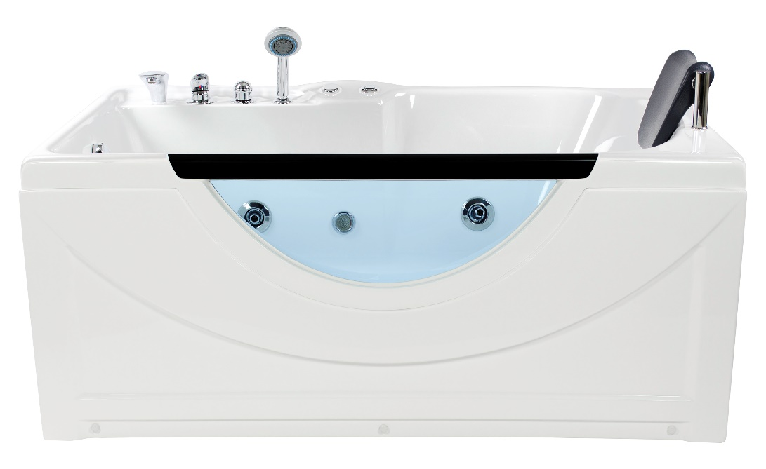

Manual Rev Date: 06.2020

Table of Contents
General Information - 2 -
Notice to Installers - 2 -
Electrical Parameters - 2 -
Electrical Requirements - 2 -
Plumbing Requirements - 2 -
Tub Diagrams - 3 -
Tub Features - 4 -
Tub Installation - 5 -
Installation of Drain - 5 -
Tub Operation - 5 -
Troubleshooting - 6 -
Cleaning and Maintenance - 6 -
Additional information - 6 -
To Expedite Part Requests: - 6 -
Warranty Information & Registration: - 6 -
Customer Reviews: - 6 -
Notes: - 7 -

General Information
• Note: All tubs need to be leveled in its final resting position and have all feet touching the ground.
• It is advised to have tub onsite before preparing drain location.
• Note: Unit comes with a 1500-watt inline heater. The heater comes on automatically when the water pump is engaged.
• Manufacturer reserves the right to change specs or features at any time. Please check to confirm details. 1-866-783-2661

Notice to Installers
THE FLEXIBLE DRAIN HOSE THAT IS INCLUDED WITH THIS UNIT IS FOR INSTALLATION INTO AN OPEN FLOOR DRAIN ONLY. SUBSTITUTING THE EXISTING DRAIN SHOE FOR A DIFFERENT ONE WILL NOT VOID THE WARRANTY AS LONG AS THERE IS NO DAMAGE OR EVIDENCE OF MISUSE TO THE BASE.

Electrical Parameters
Rated Voltage | Frequency | Motor Power
110V~120V | 60HZ | 0.745KW(1HP)/1.0KW 5.5-6.5 Amps
110V~120V | 60HZ | 1500 Watt / 13-14 Amps Inline Heater (Pre-wired)

Electrical Requirements
• 1 dedicated 10-2 line for water pump (line 1, ground and neutral)
• 110-volt, 30-amp GFCI breaker
• Includes 1500-watt inline water heater

Plumbing Requirements
• The unit is equipped with hot and cold, metal braided ½ inch water supply hose with ½ national pipe thread.
• Need to install accessible hot and cold shutoffs with ½ -male national pipe thread (not included).
• Supply hoses are to connect from the manifold on the unit to the shutoff valves.
• All water jet features are pre plumbed with reinforced braided flexible supply hose
• All fixtures and fittings should be checked for tightness as they may have come loose during transport. Access panel area advised.

Tub Diagrams
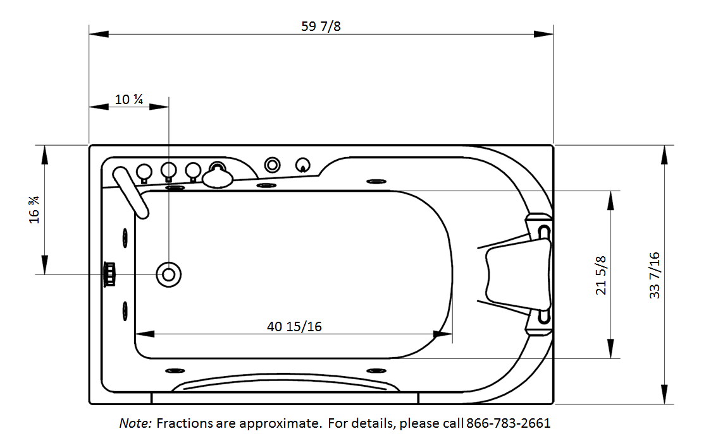

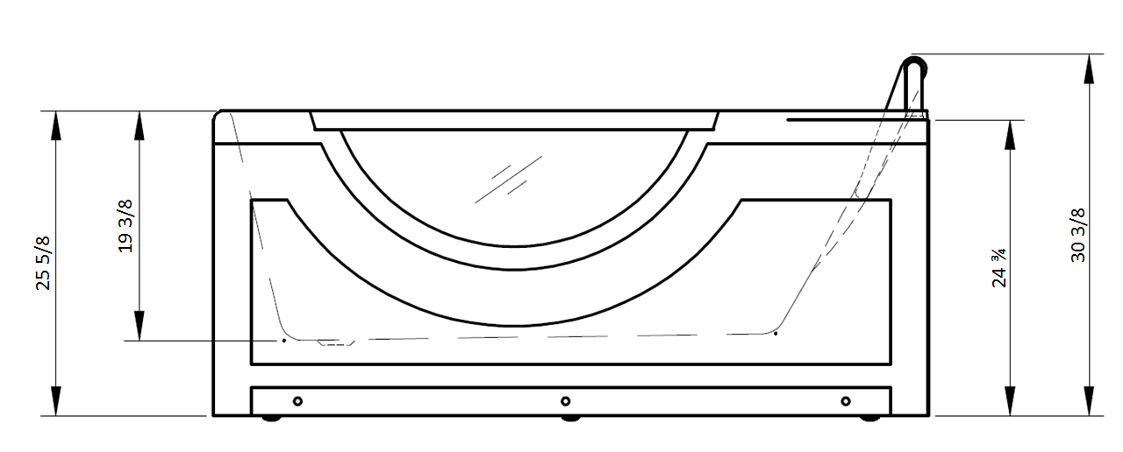

Tub Features
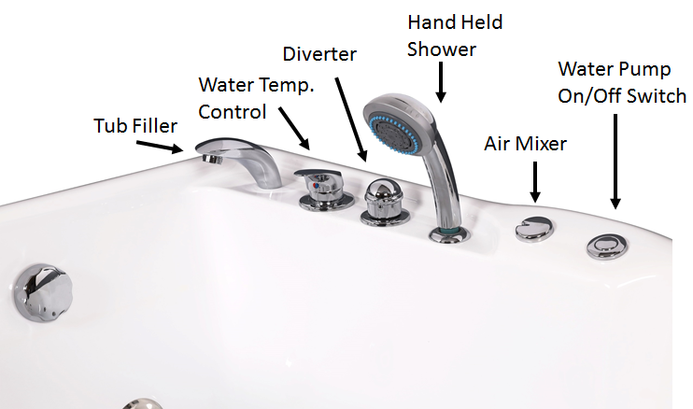

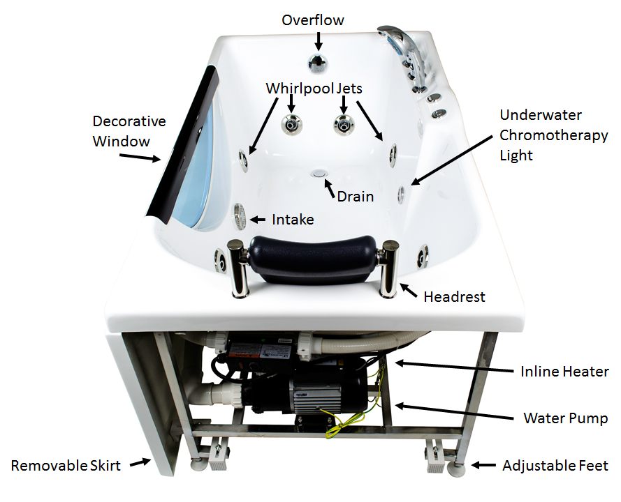

Tub Installation
Water Manifold Controls: One cold water supply pipe, one hot water supply pipe.

Drainage: The diameter of the drain should be (greater than or equal to) 40mm. This drainage can be at a distance of 300-400mm from the location we show on the chart.

- Unpack the bathtub and move it into the desired position.
- Adjust the tub feet so the water will drain completely from the tub. All feet need to be touching the floor and tub needs to be level.
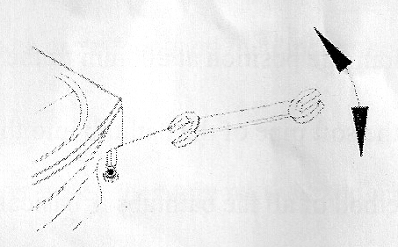
- Install the hand held spray wand
- Install the headrests.
- Ground the bathtub for safety.
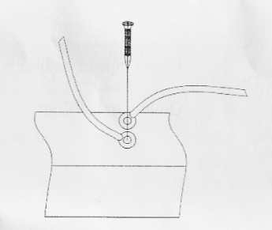

Installation of Drain
Floor drain must have trap installed

Tub Operation
- Check the power supply and GFCI protection. Insert the plug into an interior power supply socket or hardwire to a junction box (Not Included).
- Turn on the cold and hot water shut off valves, and then turn on the handle of the cold and hot water faucet to mix the water to a desirable temperature.
- Operation of the faucets: an on/off valve has been set for the shower and whirlpool bath. Turn diverter to switch between water faucet and sprayer functions.
- Whirlpool bath massage: Turn valve on. Turn off the water when it reaches the water level. Water pump valve controls the whirlpool massage pump and jets.
- Drain water for about 10 minutes after installation to clear drain lines and test for water leaks.
- After using, shut off water and power supply.

Troubleshooting
Trouble | Reason | Solution
No Power | - Power plug is not connected to the socket  - Circuit breaker is not on  - Breaker trips | - Tightly reconnect the plug with the socket.  - Reset the circuit breaker.  - Find and remove short circuit, reset the protection switch.
Water pipe leaks | - Poor seal ring  - Poor joint connection  - Water pipe is broken | - Replace  - Connect it again  - Replace
Tub light doesn’t work | - Bulb is damaged  - Wires are cut off | - Replace (remove the nut and install a new bulb, then tighten it)  - Connect the wire

Cleaning and Maintenance
- Clean the bathtub with ordinary liquid detergent and a soft cloth. Don’t sterilize the bathtub with cleaning products containing acetone or ammonia. Do not disinfect using agents with formic acid or formaldehyde.
- If scratched treat the surface with an acrylic rubbing polish.
- Wipe off the dirt and stains on surface with toothpaste and a soft cloth.
- Grind the light scratches or stains with 2000# sand paper, and then polish with polishing wax.
- If water is hard, it is suggested to clean the massage the device twice a year according to this following method:
  - Feed 40°C warm water into the bathtub until it reaches the lowest water level.
  - Mix 2g of liquid detergent for every liter of water, pour in and start the water force massage device and allow it to run for about 5 minutes.
  - Stop the water pump and drain out the water.
  - Fill the bathtub again with cold water and start the massage jets for about for 3 more minutes.
  - Stop the water pump, drain out the water, and clean the bathtub.

Additional information

To Expedite Part Requests:
Visit homewardbath.com/support

Warranty Information & Registration:
A full description of the warranty is available on the Homeward Bath website.

To Register, visit homewardbath.com/warranty-registration
Note: Registration must be completed within 45 days of receipt to be valid.

Customer Reviews:
Customer satisfaction is very important to us.
We would like to have your final installation picture(s) for publicity purposes.
Please send to Marketing at: marketing@hwbpro.com

Notes:

22900 Miles Rd
Cleveland, OH 44128
Phone: 866-783-2661
Fax: 440-348-2336
www.homewardbath.com





